2. Git-HOL
Name: Rishi Gupta
Week: Week - 7
Topic: Git Ignore

Objective
The objective of this exercise was to understand how the .gitignore file works and how Git can be configured to ignore unwanted files and folders before they are committed.

Procedure

Step 1: Created the required files and folders
Created the .gitignore file along with application.log, debug.log and the logs folder inside the Week 7 Git-HOL exercise.
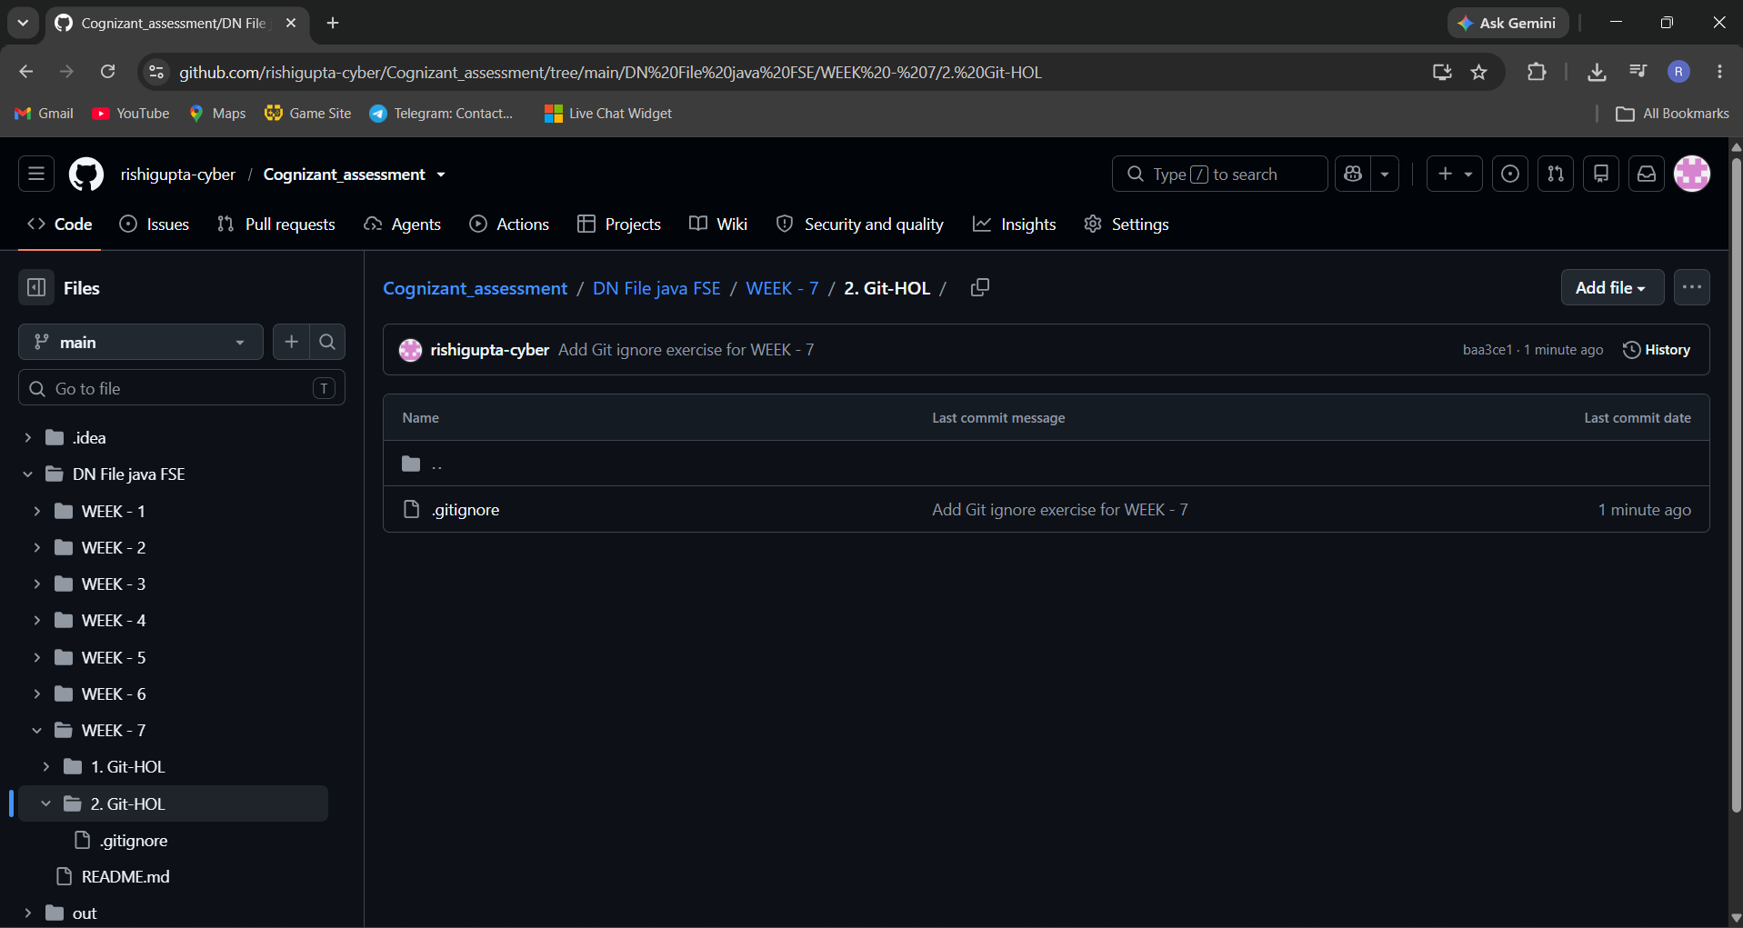

Step 2: Configured .gitignore
Added rules to ignore all .log files and the logs folder.
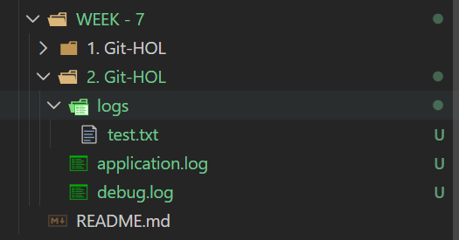

Step 3: Verified git status
Verified that only .gitignore appeared as an untracked file while the log files and logs folder were ignored.
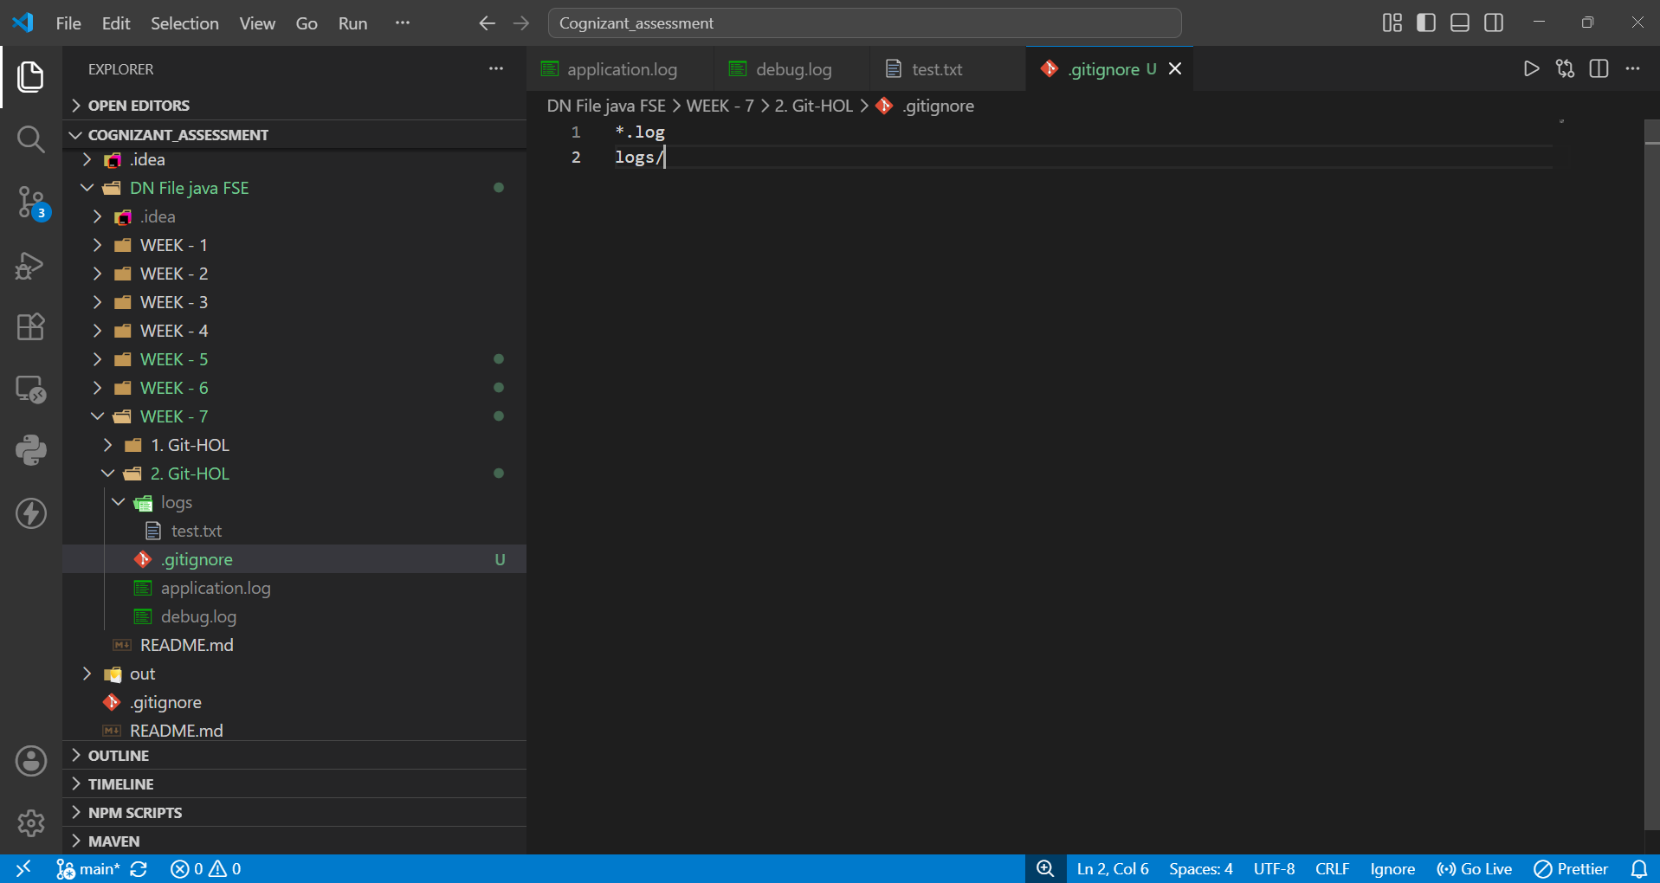

Step 4: Staged the exercise
Staged only the Week 7 Git-HOL exercise using git add and verified the staged changes.
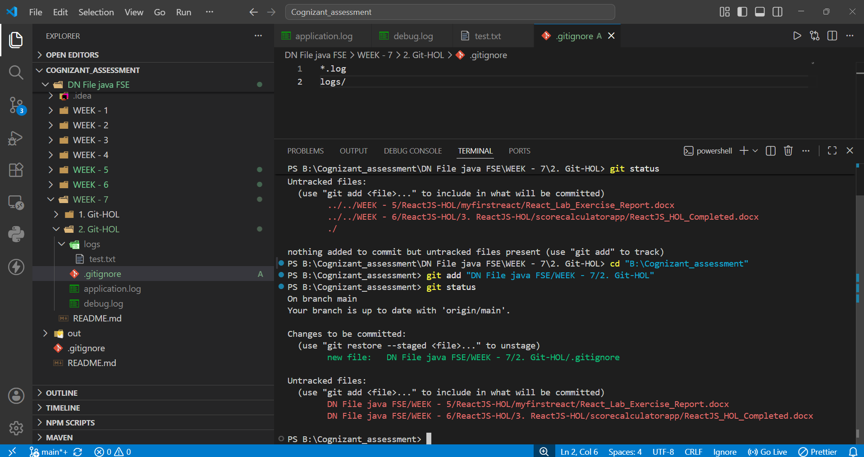

Step 5: Commit and Push
Committed the .gitignore file and pushed the changes successfully to the GitHub repository.
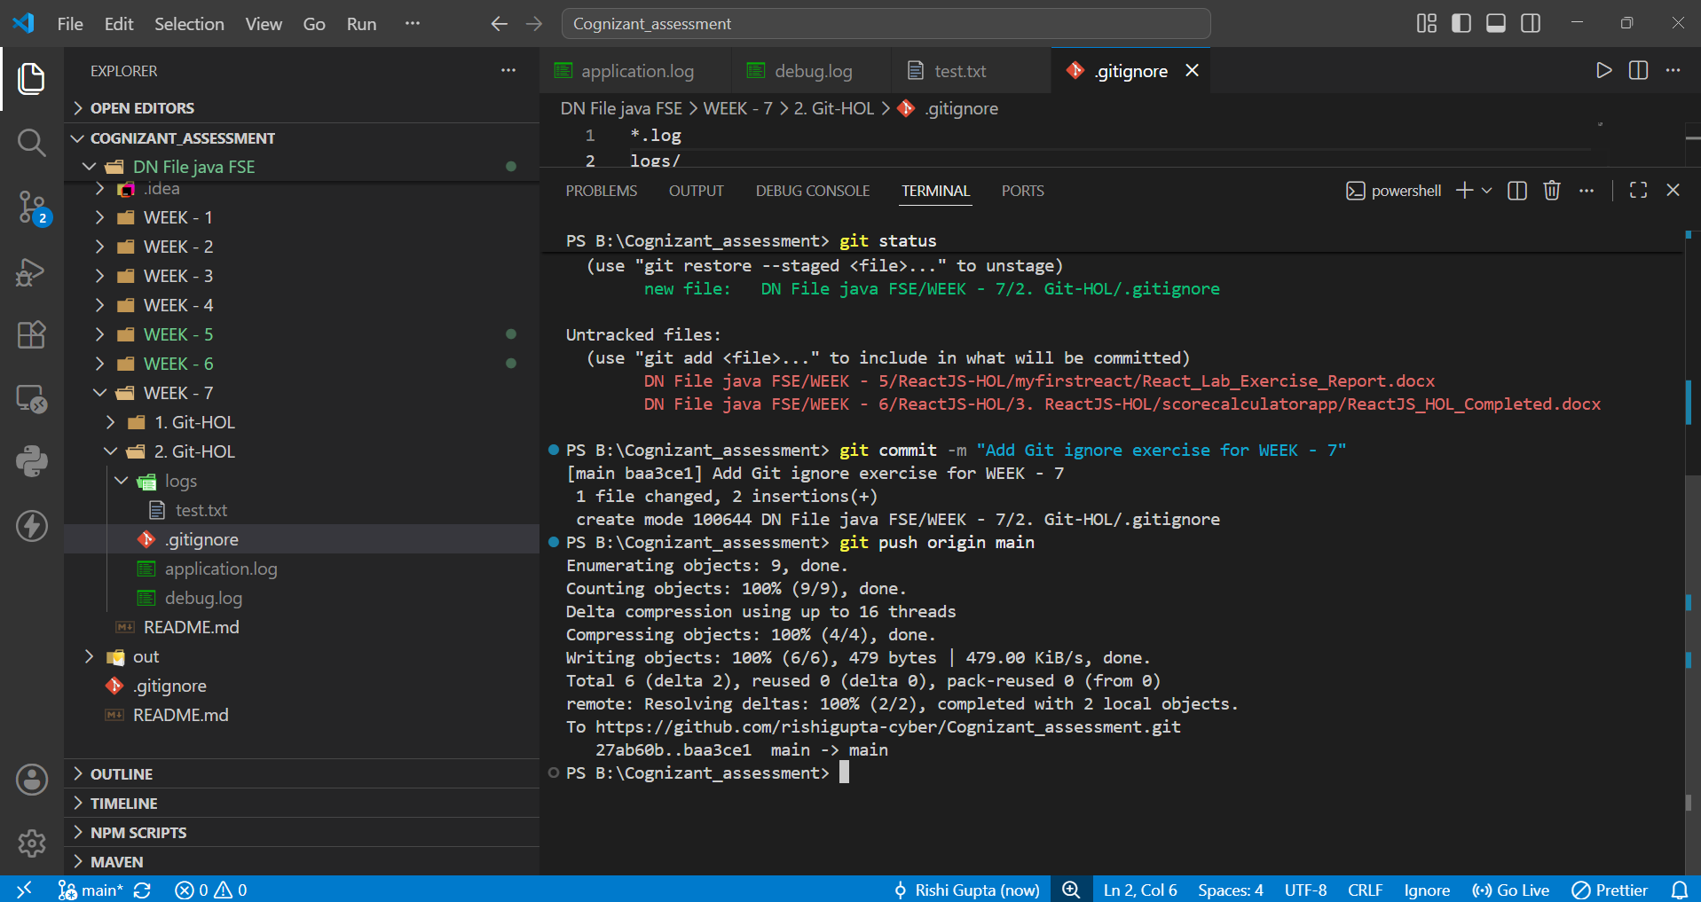

Observation
After creating the .gitignore file with the required rules, Git ignored all .log files and the logs directory. Only the .gitignore file was tracked, committed, and uploaded to the GitHub repository.

Conclusion
This exercise helped me understand the practical use of the .gitignore file. I successfully ignored unnecessary files and folders, verified the Git status, committed the required file, and pushed the changes to the remote GitHub repository.

